**10 SCIENCE 2015**

### CHEMISTRY TEST TWO

Name: _____________________________ Mark: /50

**Percentage: %**

**SECTION A: MULTIPLE CHOICE (10 marks)**

Please answer on the answer grid below.

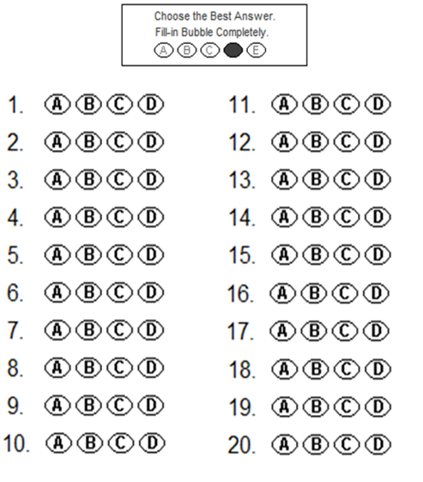



**1.** Select the incorrect statement about catalysts.

(a) Catalysts increase the amount of energy needed to convert reactants into products.

(b) Catalysts make it easier for reactant molecules to collide and form products.

(c) Catalysts speed up chemical reactions.

(d) Catalysts are not used up during reactions.

**2.** Choose the missing words for this statement.

If a solid **______________** is divided into smaller pieces, more of the solid is exposed to the liquid reactant and the rate of reaction is **_______________**.

(a) Reactant, increased.

(b) Product, increased.

(c) Product, decreased.

(d) Reactant, decreased.

**3.** Choose the correct definition for ‘ions’.

(a) Particles that have the same number of protons and electrons.

(b) Particles that have no charge.

(c) Particles that have more neutrons than protons.

(d) Particles that have a charge.

**4.** A cation is an atom that has a:

(a) Negative charge.

(b) Positive charge.

(c) No charge.

(d) Neutral charge.

**5.** AgNO3 has the compound name:

(a) Argon nitrite.

(b) Silver nitrate.

(c) Silver nitrite.

(d) Argon nitrate.

**6.** The chemical formula for boron oxide is:

(a) BO

(b) B2O3

(c) BaO

(d) B3O2

**7.** An aqueous solution is:

(a) a solution of a substance dissolved in an acid.

(b) a solution of a substance dissolved in water.

(c) a solution of aqua.

(d) a solution of two different chemicals.

**8.** The general name for the chemicals that take part in a chemical reaction is:

(a) atoms.

(b) molecules.

(c) products.

(d) reactants.

**9.** “Matter cannot be created or destroyed during a chemical reaction” is known as:

(a) the law of conversation of mass.

(b) the law of creation of mass.

(c) the law of conservation of mass

(d) the law of conservation of energy.

**10.** Choose the equation that is not balanced.

(a) C5H12 + 4O2 🡪 CO2 + 6H2O

(b) Mg + 2HCL 🡪 MgCl2 + H2

(c) 4Al + 3O2 🡪 2Al2O3

(d) 2Zn + O2 🡪 2ZnO

**SECTION B: SHORT ANSWER (40 marks)**

**1.** List three things that affect the rate of chemical reactions. (3 marks)

_____________________________________________________________________________________

_____________________________________________________________________________________

_____________________________________________________________________________________

**2.** **Explain** how agitation increases the rate of reaction of a chemical reaction. (2 marks)

_____________________________________________________________________________________

_____________________________________________________________________________________

_____________________________________________________________________________________

**3.** Explain the effect of the following changes on a wood fire heater. (4 marks)

**a)** The wood is chopped into smaller pieces.

_____________________________________________________________________________________

_____________________________________________________________________________________

_____________________________________________________________________________________

_____________________________________________________________________________________

_____________________________________________________________________________________

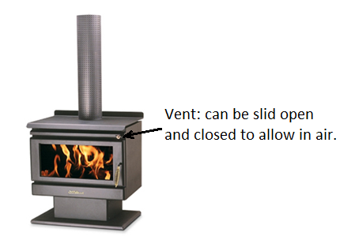**b)** The vent is closed so that less air can get in.

____________________________________________________________

____________________________________________________________

____________________________________________________________

____________________________________________________________

____________________________________________________________

____________________________________________________________

____________________________________________________________

**4.** State what the arrow (🡪) means in chemical equations. (1 mark)

_____________________________________________________________________________________

**5.** Balance the chemical equations below. (14 marks)

**a)** Na + Cl2 🡪 NaCl

**b)** Al + O2 🡪 Al2O3

**c)** S8 + O2 🡪 SO2

**d)** Ca + H20 🡪 Ca(OH)2 + H2

**e)** V2O5 + CaS 🡪 CaO + V2S5

**f)** Fe2O3 + C 🡪 CO2 + Fe

**g)** Al + HCl 🡪 AlCl3 + H2

**6.** Write the **chemical formula** for each of the following substances and include the appropriate **state** ( s, l, g, or aq ) for each one. (6 marks)

**a)**  Hydrogen

_____________________________________________________________________________________

**b)** Potassium carbonate crystals

_____________________________________________________________________________________

**c)** Dilute sulfuric acid

_____________________________________________________________________________________

**d)** Dilute hydrochloric acid

_____________________________________________________________________________________

**e)** Water

_____________________________________________________________________________________

**f)** Calcium carbonate

_____________________________________________________________________________________

**7.** Clear silver nitrate solution is mixed with a clear sodium chloride solution. White silver chloride (solid) precipitates out, leaving behind a clear solution of sodium nitrate.

**a)**  Write a word equation for the above reaction. (1 mark)

**b)**  Write a balanced formula equation including the states of each substance. (2 marks)

**8 a)** Give an example of a chemical reaction that has a slow rate of reaction. (1 mark)

**b)** Give an example of a chemical reaction that has a fast rate of reaction. (1 mark)

**9.** A chemist is developing a new chemical reaction for converting iron ore into iron metal. She wants to work out how adding a catalyst changes the rate of reaction. To do this, she measures the amount of iron metal produced by the chemical reaction every minute for the first 5 minutes. Her data is in the table below.

Draw a graph using the information from the table below. (5 marks)

Don’t forget all the things that a graph needs!

|  |  |
| --- | --- |
| **Time (minutes)** | **Iron produced (g)** |
| 0 | 0 |
| 1 | 20 |
| 2 | 42 |
| 3 | 53 |
| 4 | 60 |
| 5 | 68 |

[](http://www.google.com.au/url?sa=i&rct=j&q=graph+paper&source=images&cd=&cad=rja&uact=8&docid=bnDyK-WDEHhooM&tbnid=OH_xw5ZTcFEuvM:&ved=0CAUQjRw&url=http://virtualmathtutor.blogspot.com/2010/11/how-to-draw-circle-without-compass.html&ei=RKw4U5fxF8fClQWCrIGoCQ&psig=AFQjCNHahbsWAgdANQM5RZCXw4z48cLLBw&ust=1396309252654415)

**Table of common ions**

|  |  |
| --- | --- |
| **+1 charge** | **- 1 charge** |
| Hydrogen H+  Lithium Li+  Sodium Na+  Potassium K+  Copper (I) Cu+  Silver Ag+  Ammonium NH4+ | Fluoride F-  ChlorideCl-  Bromide Br-  Iodide I-  Hydride H-  Hydroxide OH-  Nitrite NO2-  Nitrate NO3- |
| **+2 charge** | **- 2 charge** |
| Manganese Mn2+  Magnesium Mg2+  Calcium Ca2+  Barium Ba2+  Zinc Zn2+  Copper (II) Cu2+  Mercury (II) Hg2+  Iron (II) Fe2+  Tin (II) Sn2+  Lead (II) Pb2+  Nickel (II) Ni2+  Beryllium Be2+ | Oxide O2-  Sulfide S2-  Carbonate CO32-  Sulfate SO42-  Sulfite SO32- |
| **+3 charge** | **- 3 charge** |
| Aluminium Al3+  Iron (III) Fe3+  Chromium (III) Cr3+  Boron B3+ | Nitride N3-  Phosphate PO43-  Phosphide P3- |